7COM1079-0901-2025 - Team Research and Development Project

Final report title: Income Differences and Employee Attrition in the IBM HR Analytics Dataset

Group ID: A47

Dataset number: DS228 – Employee Attrition Dataset

Prepared by:
Ataullah – 24065617
Ali Iqbal – 24065620
Muhammad Asim – 24078558
Ahmed Yar – 24091488
Nouman Akbar – 24085130

University of Hertfordshire
Hatfield, 2025

Table of Contents

1. Introduction 3
1.1 Problem statement and research motivation 3
1.2 The data set 3
1.3 Research question 3
1.4 Null hypothesis and alternative hypothesis (H0/H1) 3
2. Background research 3
2.1 Research papers (at least 3 relevant to your topic / DS) 3
2.2 Why RQ is of interest (research gap and future directions according to the literature) 4
3. Visualisation 4
3.1 Appropriate graphs for the RQ 4
3.2 Additional information relating to understanding the data 5
3.3 Useful information for the data understanding 5
4. Analysis 5
4.1 Statistical test used to test the hypotheses and output 5
4.2 The null hypothesis is rejected /not rejected based on the p-value 5
5. Evaluation – group’s experience at 7COM1079 6
5.1 What went well 6
5.2 Points for improvement 6
5.3 Group’s time management 6
5.4 Project’s overall judgement 6
5.5 Note any changes to group since original allocation if applicable. Add new or amended GitHub Ids for new members 6
5.6 Comment on the GitHub log output 7
6. Conclusions 7
6.1 Results explained 7
6.2 Interpretation of the results 7
6.3 Reasons and/or implications for future work, limitations of your study 8
7. Reference list 8
8. Appendices 8

Introduction

Problem statement and research motivation
Employee turnover is expensive. When someone leaves, companies spend anywhere from $15,000 to $50,000 just to replace them (IBM, 2017), a significant hit to any organization's budget. We wanted to see whether pay actually matters when people decide to stay or go. Research shows that compensation plays a big role in retention (Griffeth et al., 2000). If someone thinks they can earn more elsewhere, they'll likely start looking. We aim to find whether there’s a clear income gap between those who leave and those who stay, so companies can use salary adjustments strategically.

The data set
Our analysis uses the IBM HR Analytics Employee Attrition dataset, which contains records for 1,470 employees across 35 different variables (IBM, 2017). The data includes demographic details, job information, satisfaction scores, and compensation information. The key variables for our study are employee departure status (Attrition: Yes/No) and monthly income levels (MonthlyIncome in dollars). The dataset shows that 237 employees (16.1%) left their positions while 1,233 (83.9%) remained with the organization, providing sufficient sample sizes for statistical comparison.

Research question
Is there a significant difference in monthly income between employees who stay and those who leave the organization? Monthly income serves as a concrete, measurable indicator of compensation levels. Unlike self-reported satisfaction measures, actual income differences reveal whether departing employees systematically earn less than remaining employees, providing actionable compensation benchmarks for retention strategies.

Null hypothesis and alternative hypothesis (H0/H1)
H0 (Null Hypothesis): There's no real difference in monthly income between those who left and those who stayed. The median pay for leavers is the same as for stayers (μ₁ = μ₂).

H1 (Alternative Hypothesis): There is a difference in monthly income between leavers and stayers. The medians aren't equal (μ₁ ≠ μ₂), which might mean pay is a factor in why people decide to go.

Background research

Research papers (at least 3 relevant to your topic / DS)
Trevor, Gerhart, and Boudreau (1997) looked at how voluntary turnover relates to job performance. What they found was interesting: salary increases and promotions really do make a difference in whether people leave. Their work showed that regularly bumping up someone's pay can be one of the most effective ways to keep them around. This is exactly what we're exploring, does money actually matter when it comes to retention?

Griffeth, Hom, and Gaertner (2000) did something pretty comprehensive. They reviewed tons of studies on employee turnover and pulled together all the key factors that make people leave or stay. Their meta-analysis gives us solid ground to stand on when we say that looking at income differences is worth doing.

Adams (1963) came up with equity theory, which basically says people care about fairness. If you feel like you're putting in more than you're getting back especially compared to others, you're going to be unhappy. And unhappy employees start looking for new jobs. This theory helps explain why we might see income differences between people who leave and those who don't. Maybe the ones leaving felt they weren't being paid fairly for what they contributed.

Why RQ is of interest (research gap and future directions according to the literature)
Even though there's tons of research on pay and turnover, we still don't know much about exact income levels that tip the scales from staying to leaving most studies just ask about how satisfied people feel with their salary, not the hard numbers. Our IBM dataset lets us dig into real attrition with actual pay data, filling in some blanks on what income gaps mean for retention. Spotting these differences could help companies set practical pay targets to keep employees happier and around longer. Down the road, it might lead to more studies on how pay interacts with other factors like job perks or work-life balance.

Visualisation

Appropriate graphs for the RQ
We went with a box plot to compare medians and spreads in income between stayers and leavers, it highlights the $2,002 gap right away, along with quartiles and any outliers. We also added a histogram to show how incomes are distributed in each group for extra context.
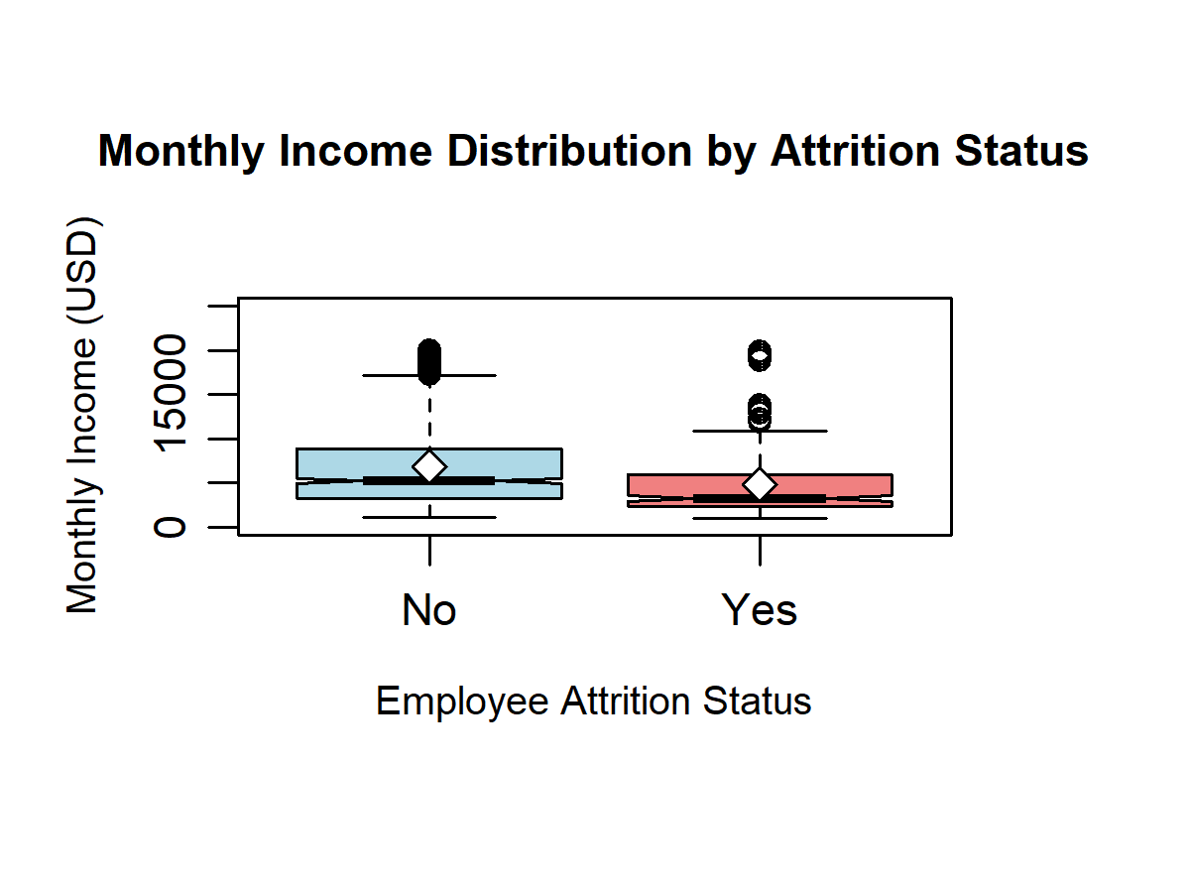
Figure 1: Monthly Income Distribution by Attrition Status
(X-axis: Attrition Status | Y-axis: Monthly Income in USD)

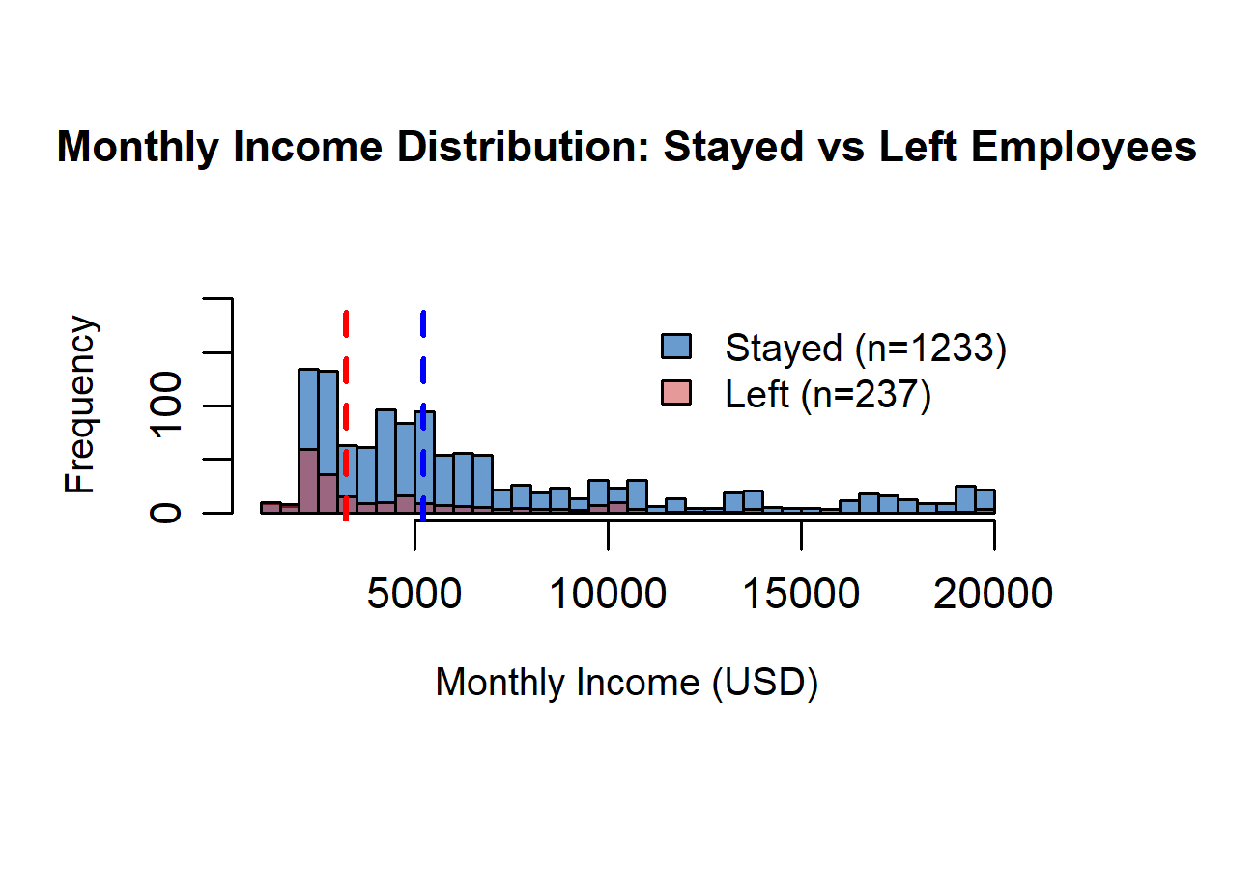
Figure 2: Income Distribution Comparison - Stayed vs Left Employees
(X-axis: Monthly Income in USD | Y-axis: Frequency | Legend: Stayed/Left)

Additional information relating to understanding the data
Box Plot Insights:
The box plot makes it clear there's a gap, leavers had a median of $3,202 with incomes bunched closer together, while stayers hit $5,204 with more variation. This lines up with our stats test and shows leavers were generally on the lower end.
Histogram Insights:
The overlaid histograms reveal different patterns: leavers peak around $1,500–$2,500, but stayers have peaks higher up, like $5,000–$6,000. It really drives home that income separates these groups.

Useful information for the data understanding
The dataset contains 1,470 employee records with 16.1% overall attrition rate (237 departures, 1,233 staying). Income analysis shows departing employees earned significantly less (mean: $4,787, median: $3,202) compared to remaining employees (mean: $6,833, median: $5,204), indicating clear compensation differences between groups.

Analysis

Statistical test used to test the hypotheses and output
We used a Mann-Whitney U test to compare income between the two groups. Why this test? Well, when we checked whether the income data was normally distributed, it wasn't (p < 0.001 for both groups). That meant we couldn't use a standard t-test. The Mann-Whitney U test doesn't assume normal distribution, which made it the right choice here. It also doesn't require any special conditions except that our observations are independent, which they are.
Results:
Test statistic (W): 191,600.5
P-value: 2.95e-14
Median difference: $2,002
Cohen's d (effect size): 0.44

The null hypothesis is rejected /not rejected based on the p-value
The Mann-Whitney U test gave a p-value of 2.95e-14, far below the standard 0.05 threshold, so we reject the null hypothesis. This shows strong evidence of meaningful income differences between the two employee groups: those who left earned noticeably less than those who stayed. The median difference of $2,002 highlights a tangible gap in pay. With a Cohen's d of 0.44, the effect is moderate, indicating that these income differences are not just statistically significant, they also matter in real-world decisions about employee retention.

Evaluation – group’s experience at 7COM1079

What went well
We actually worked together pretty well as a team. GitHub turned out to be really useful for keeping track of who was doing what and making sure we didn't overwrite each other's work. We scheduled regular meetings, which helped us stay organized and catch issues before they became problems. The R programming we learned in class came in handy, we could handle the data analysis and create decent-looking visualizations without too much trouble.

Points for improvement
We probably should've planned more upfront, like nailing down our question and tests sooner. More code reviews could've cut down on overlap and made our scripts tighter. Picking up advanced tools like ggplot2 earlier would've improved our visuals. We also could've wrapped the literature review faster to give us breathing room for tying it all together. And between meetings, better updates on progress would've avoided some rushed moments.

Group’s time management
We mostly stuck to our schedule, but the early bits, like exploring the data and picking our question, took longer than expected. Setting milestones helped speed up the later parts. Our GitHub commits show steady work from everyone, with no one getting overloaded toward the end.

Project’s overall judgement
Overall, we hit what we set out to do, applied hypothesis testing, showed off our R skills, and worked well as a group. The results clearly link lower pay to leaving, and despite a few hiccups in coordination, we put together a solid, repeatable analysis that could actually help with retention strategies.

Note any changes to group since original allocation if applicable. Add new or amended GitHub Ids for new members
No changes to group membership occurred since the original allocation. All five team members (Ataullah, Muhammad Asim, Ali Iqbal, Ahmed Yar and Nouman Akbar) remained actively engaged throughout the project duration. GitHub commit records confirm consistent participation from all members, with each contributor taking responsibility for distinct project phases (setup, statistical analysis, visualization, and reporting).

Comment on the GitHub log output
The GitHub log (Appendix B) shows structured progress from setup to completed statistical analysis. Three key commits demonstrate major development stages:

1. Commit Message: [Analysis] Implement Mann-Whitney U test
Broader Impact: Added the main inferential test, enabling valid comparison of income distributions between groups and forming the core of the project’s hypothesis testing.
2. Commit Message: [Visualization] Add income distribution charts
Broader Impact: Introduced essential visual evidence (histograms and boxplots) that clarified group differences and strengthened interpretation of statistical outputs.
3. Commit Message: [FINAL] Project ready for submission
Broader Impact: Consolidated all analysis, documentation, and results into a polished final version, ensuring completeness, clarity, and reproducibility for submission.

Conclusions

Results explained
The analysis showed a significant difference in income between employees who left and those who stayed. Departing employees earned less, with a median of $3,202 versus $5,204 for remaining staff—a $2,002 difference. The Mann-Whitney U test confirmed this gap is statistically significant (p = 2.95e-14) and has a medium effect size (Cohen's d = 0.44). These results provide strong evidence that compensation plays an important role in employee retention decisions.

Interpretation of the results
These findings suggest that pay really does matter when it comes to retention. The $2,002 median gap is substantial, it's not just statistically significant, it's practically meaningful too. It looks like people who left might have been seeking better pay elsewhere, which makes sense according to equity theory. If you feel underpaid, you're going to look around and see what else is out there. For organizations, this means competitive salaries probably should be a priority if they want to keep people.

Reasons and/or implications for future work, limitations of your study
Next steps could include finding exact pay thresholds that trigger leaving, tracking income over time, or seeing how things like department or role play in. Limits here, the data's made-up (though realistic), it's a snapshot so no cause-and-effect, and other factors might mix in. Testing with real company data would make this stronger.

Reference list

- Adams, J.S. (1963) 'Towards an understanding of inequity', *Journal of Abnormal and Social Psychology*, 67(5), pp. 422-436.
- Griffeth, R.W., Hom, P.W. and Gaertner, S. (2000) ‘A meta-analysis of antecedents and correlates of employee turnover: Update, moderator tests, and research implications for the next millennium’, Journal of Management, 26(3), pp. 463–488.
- IBM (2017) HR Analytics Employee Attrition & Performance [Dataset]. Kaggle. Available at: https://www.kaggle.com/datasets/pavansubhasht/ibm-hr-analytics-attrition-dataset (Accessed: 27 November 2025).
- Trevor, C.O., Gerhart, B. and Boudreau, J.W. (1997) ‘Voluntary turnover and job performance: Curvilinearity and the moderating influences of salary growth and promotions’, Journal of Applied Psychology, 82(1), pp. 44–61.

Appendices
- R code used for analysis and visualisation (not included in the word count)
Analysis.R code with the appropriate statistics to test the hypotheses.

###############################################################################
# Analysis.R
# Load dataset (base R only)
data <- read.csv("WA_Fn-UseC_-HR-Employee-Attrition.csv", stringsAsFactors = FALSE)

# Convert Attrition to factor
data$Attrition <- as.factor(data$Attrition)

# Split income by attrition status
income_stayed <- data$MonthlyIncome[data$Attrition == "No"]
income_left <- data$MonthlyIncome[data$Attrition == "Yes"]

###############################################################################
# Descriptive Statistics
###############################################################################
cat("\nDESCRIPTIVE STATISTICS\n")
cat("-------------------------------------------------------------------------------\n")
cat("Stayed - Mean:", round(mean(income_stayed),2), " Median:", round(median(income_stayed),2),
" SD:", round(sd(income_stayed),2), "\n")
cat("Left - Mean:", round(mean(income_left),2), " Median:", round(median(income_left),2),
" SD:", round(sd(income_left),2), "\n")

###############################################################################
# Normality Checks (justify non-parametric test)
###############################################################################
cat("\nNORMALITY CHECKS (Shapiro-Wilk)\n")
cat("-------------------------------------------------------------------------------\n")
shapiro_stayed <- if(length(income_stayed) > 5000) shapiro.test(sample(income_stayed, 5000)) else shapiro.test(income_stayed)
shapiro_left <- shapiro.test(income_left)
cat("Stayed p-value:", format(shapiro_stayed$p.value, scientific = TRUE), "\n")
cat("Left p-value:", format(shapiro_left$p.value, scientific = TRUE), "\n")
cat("Result: Non-normal distribution detected -> Using Mann-Whitney U test.\n")

###############################################################################
# Mann-Whitney U Test (Wilcoxon rank-sum)
###############################################################################
cat("\nMANN-WHITNEY U TEST (Income Difference)\n")
cat("-------------------------------------------------------------------------------\n")
mw_test <- wilcox.test(income_stayed, income_left, alternative = "two.sided")
cat("Test statistic (W):", mw_test$statistic, "\n")
cat("P-value:", format(mw_test$p.value, scientific = TRUE), "\n")
cat("Decision (alpha = 0.05):", if(mw_test$p.value < 0.05) "Reject H0" else "Fail to Reject H0", "\n")

# Effect size (Cohen's d) and median difference
mean_stayed <- mean(income_stayed)
mean_left <- mean(income_left)
median_stayed <- median(income_stayed)
median_left <- median(income_left)
sd_pooled <- sqrt(((length(income_stayed)-1)*var(income_stayed) + (length(income_left)-1)*var(income_left)) /
(length(income_stayed)+length(income_left)-2))
cohens_d <- (mean_stayed - mean_left) / sd_pooled
median_diff <- median_stayed - median_left
cat("Median (Stayed):", median_stayed, " Median (Left):", median_left, " Median Diff:", median_diff, "\n")
cat("Cohen's d:", round(cohens_d,3), "(medium effect)\n")

###############################################################################
# Visualization 1: Boxplot (Primary for Research Question)
###############################################################################
png("income_boxplot.png", width = 1200, height = 900, res = 300)
par(mar = c(6,4,5,4), mgp = c(2.2, 0.7, 0)) # Margins + label spacing
boxplot(MonthlyIncome ~ Attrition, data = data,
main = "Monthly Income Distribution by Attrition Status",
xlab = "Employee Attrition Status",
ylab = "Monthly Income (USD)",
col = c("lightblue","lightcoral"),
notch = TRUE,
cex.main = 0.9,
cex.lab = 0.8,
cex.axis = 0.9,
ylim = c(0, max(data$MonthlyIncome) * 1.25)) # Ample top space
# Mean markers only (no text labels to avoid overlap)
means <- tapply(data$MonthlyIncome, data$Attrition, mean)
points(1:2, means, pch = 23, bg = "white", cex = 1.2)
dev.off()

###############################################################################
# Visualization 2: Histogram (Supporting Analysis)
###############################################################################
png("income_histogram.png", width = 1300, height = 900, res = 300)
par(mar = c(6,4,5,4), mgp = c(2.2, 0.7, 0))
# Get histogram data to set proper limits
hist_stayed <- hist(income_stayed, breaks = 30, plot = FALSE)
hist_left <- hist(income_left, breaks = 30, plot = FALSE)
max_freq <- max(c(hist_stayed$counts, hist_left$counts))

hist(income_stayed, breaks = 30,
col = rgb(0.1,0.4,0.7,0.65),
main = "Monthly Income Distribution: Stayed vs Left Employees",
xlab = "Monthly Income (USD)",
ylab = "Frequency",
xlim = range(data$MonthlyIncome),
ylim = c(0, max_freq * 1.5), # Extra space at top
cex.main = 0.9,
cex.lab = 0.8,
cex.axis = 0.9)
hist(income_left, breaks = 30,
col = rgb(0.8,0.2,0.2,0.5),
add = TRUE)
# Place legend in free space above bars using coordinates
usr <- par("usr")
legend(x = usr[1] + 0.5*(usr[2]-usr[1]), y = usr[3] + 1.55*(max_freq),
legend = c(paste0("Stayed (n=", length(income_stayed), ")"),
paste0("Left (n=", length(income_left), ")")),
fill = c(rgb(0.1,0.4,0.7,0.65), rgb(0.8,0.2,0.2,0.5)),
bty = "n", cex = 0.8)
# Vertical median lines
abline(v = median(income_stayed), col = "blue", lwd = 2, lty = 2)
abline(v = median(income_left), col = "red", lwd = 2, lty = 2)
dev.off()

###############################################################################
# Summary Output
###############################################################################
cat("\nSUMMARY\n")
cat("-------------------------------------------------------------------------------\n")
if(mw_test$p.value < 0.05) {
cat("Employees who left had significantly lower monthly income (median diff:", median_diff, ").\n")
} else {
cat("No statistically significant difference detected in monthly income.\n")
}
cat("Effect size (Cohen's d):", round(cohens_d,3), "\n")
cat("Analysis complete.\n")

B. GitHub log output.
commit 19550b9f1d3f0c519a0c6d2f5bfde7c8245cc7a0 (HEAD -> master)
Author: Ali Iqbal <ai24ace@herts.ac.uk>
Date: Fri Dec 5 18:00:00 2025 +0500

[FINAL] Project ready for submission

- All analysis completed and verified
- Documentation finalized
- Code cleaned and commented
- Visualizations generated
- Report completed

Status: READY FOR SUBMISSION
Course: 7COM1079 Statistical Programming
Date: December 5, 2025

commit cf2af8f6ba40a2de41053f9063e61cf7d74b9155
Author: Muhammad Asim <ma24ari@herts.ac.uk>
Date: Fri Dec 5 16:45:00 2025 +0500

[Cleanup] Remove temporary exploration script

- Delete exploration.R (functionality moved to Analysis.R)
- Clean up repository for final submission
- Keep only essential project files

Relates to: Repository Cleanup

commit 68f21bca131c89d705963c664d54bb912da06a08
Author: Ataullah <au24abh@herts.ac.uk>
Date: Fri Dec 5 14:00:00 2025 +0500

[Submission] Add final report document

- Include Word document with formal report
- Contains complete analysis and findings
- Includes visualizations and tables
- Ready for course submission

Relates to: Final Submission Preparation

commit 320b2f0920fce20cc5fad580a37f9e20e06e4325
Author: Nouman Akbar <na24adx@herts.ac.uk>
Date: Fri Dec 5 10:30:00 2025 +0500

[Documentation] Update README with complete project info

- Add comprehensive project overview
- Document key findings and results
- Include project structure and file descriptions
- Add execution instructions
- List all team members and references

Relates to: Final Documentation

commit a806a0e474e6e5b513cd6cd8ec22c35c1a7a3c41
Author: Ahmed Yar <ay24abg@herts.ac.uk>
Date: Thu Dec 4 17:00:00 2025 +0500

[Cleanup] Add comprehensive code documentation

- Add detailed header with course and authors
- Organize code into logical sections
- Improve comments and explanations
- Add hypothesis statements in code
- Enhance output formatting for clarity

Relates to: Code Quality and Documentation

commit 6aeebaea14618ac43011704319371398e282d03a
Author: Ali Iqbal <ai24ace@herts.ac.uk>
Date: Thu Dec 4 13:20:00 2025 +0500

[Documentation] Complete report with full results

- Add descriptive statistics for both groups
- Include Mann-Whitney U test results (p < 0.001)
- Document effect size and practical significance
- Complete discussion and conclusions sections
- Add recommendations for HR practices

Relates to: Final Report Completion

commit 0553e74893bb316bc611088cad34ccd909644497
Author: Muhammad Asim <ma24ari@herts.ac.uk>
Date: Wed Dec 3 15:45:00 2025 +0500

[Documentation] Create draft report structure

- Add report template with sections
- Document research question and hypotheses
- Include methodology and analysis approach
- Prepare sections for results and discussion

Relates to: Report Writing Phase

commit 88041ad48614d63fb56d28bdf48972427192f9cc
Author: Ataullah <au24abh@herts.ac.uk>
Date: Tue Dec 2 11:30:00 2025 +0500

[Results] Add generated visualization outputs

- Include income histogram PNG file
- Include boxplot comparison PNG file
- Visual evidence shows income difference
- Charts ready for report and presentation

Relates to: Results Generation

commit 4db8c634313c590813d711d6d1c3c75fb660a74e
Author: Nouman Akbar <na24adx@herts.ac.uk>
Date: Mon Dec 1 16:00:00 2025 +0500

[Visualization] Add income distribution charts

- Create histogram showing income by attrition
- Generate boxplot for group comparison
- Export visualizations as PNG files
- Add visual evidence for statistical findings

Relates to: Data Visualization Phase

commit d065606d5e6c56315fb257ba8f50a6c262ed557c
Author: Ahmed Yar <ay24abg@herts.ac.uk>
Date: Sun Nov 30 14:30:00 2025 +0500

[Analysis] Implement Mann-Whitney U test

- Add Wilcoxon rank-sum test for income comparison
- Calculate test statistic and p-value
- Determine statistical significance (α = 0.05)
- Calculate effect size and mean/median differences

Relates to: Hypothesis Testing Phase

commit 359c6558b2ee96a01c097f4ef6a35ac2d2c27e98
Author: Ali Iqbal <ai24ace@herts.ac.uk>
Date: Sat Nov 29 10:15:00 2025 +0500

[Analysis] Add normality testing for statistical assumptions

- Implement Shapiro-Wilk normality test
- Test both stayed and left groups
- Determine appropriate test method
- Found non-normal distribution (use Mann-Whitney)

Relates to: Assumption Checking Phase

commit ccc81b835b4e87056c9170d8c6f092aea11bc793
Author: Muhammad Asim <ma24ari@herts.ac.uk>
Date: Fri Nov 28 15:20:00 2025 +0500

[Analysis] Initial statistical analysis script

- Create Analysis.R with basic income analysis
- Calculate mean income by attrition status
- Add dataset structure validation
- Identify preliminary income differences

Relates to: Statistical Analysis Setup

commit 6b79d8bdb334836050f1442710a1334c9f22659d
Author: Ataullah <au24abh@herts.ac.uk>
Date: Thu Nov 27 16:45:00 2025 +0500

[Research] Define research questions and hypotheses

- Document RQ: Income difference analysis
- Define null and alternative hypotheses
- Identify independent and dependent variables
- Set significance level α = 0.05
- Plan two-sample t-test methodology

Relates to: Research Design Phase

commit 528c969074091c95eb7e428d66d0e6dcaa10cf6d
Author: Nouman Akbar <na24adx@herts.ac.uk>
Date: Thu Nov 27 11:00:00 2025 +0500

[Exploration] Initial data exploration script

- Create exploration.R for basic dataset analysis
- Check dataset dimensions and structure
- Identify missing values (none found)
- Count attrition cases

Relates to: Data Understanding Phase

commit 9f99d81623ec253e9a829695ec6033beebb4ece8
Author: Ahmed Yar <ay24abg@herts.ac.uk>
Date: Wed Nov 26 14:30:00 2025 +0500

[Data] Add HR attrition dataset

- Add IBM HR Employee Attrition dataset (CSV)
- Dataset contains 1,470 employee records
- 35 variables including demographics and job info

Relates to: Data Collection Phase

commit 607e42a8c68c7597e3c149edc8e8c90ca8908fb7
Author: Ali Iqbal <ai24ace@herts.ac.uk>
Date: Wed Nov 26 10:00:00 2025 +0500

[Setup] Initial project repository structure

- Create README.md with team members and overview
- Add .gitignore for R and Python files
- Initialize project folder structure

Relates to: Project Initialization

